|  |  |
| --- | --- |
| **Information Technology and Systems**  e-ISSN: 3031-1187  Homepage: [https://sanscientific.com/journal/index.php/](https://sanscientific.com/journal/index.php/rbm/)its  **x(x) xx-xx (20xx)**  https://doi.org/ |  |

*Research Article/Case Study/Review Paper****a)***

The title should be interesting, informative, and specific according to the content of the article (Max 14 words)-Trebuchet MS 14

**First author’s name1*, Second author2, Third author3 (Trebuchet MS Size 12-Bold)**

1Department, Faculty, University, City (Trebuchet MS size 10)

2Department, Faculty, University, City (size 10)

3Department, Faculty, University, City (size 10)

*Received: 202x; Accepted: 202x*

**Abstract** (Trabuchet MS 12)

The abstract written in English must contain: purpose of the article, design/methods, results/ findings, limitations/implications and novelty/originality within **200-220 words**.

**Purpose:** Here is where you discuss the "reason" of your study. Explain the issue you have resolved if you are presenting new or original research. Briefly describe why you choose to build on prior research if you are doing so. Here is your chance to explain to readers the importance of the topic or issue you selected to research. Tell them what your major argumentation or conclusion is. (Calisto MT 10)

**Design/Methodolgy/Approach:** And that's "how" you accomplished it. Explain the fact exactly what you did to reach at your findings. Did you, for instance, conduct interviews? Have you performed any lab experiments? What equipment, techniques, procedures, or data sets did you implement?

**Result/Findings:** Here, you can discuss "what" you learned from your research, whether it resolves the issue you set out to investigate, and whether your hypothesis held true. In order to avoid generalizations, you must be very plain, unambiguous, and provide precise numbers. It's crucial to avoid making overstatements or setting unrealistic expectations for your paper.

**Research limitations/implications:** Explain thelimmitations of this study/article (short and clear)

**Originality/value:** This is your chance to explain to the readers the significance of your findings. Asking your colleagues to evaluate your analysis for fairness and balance is a wonderful approach, and it's essential not to exaggerate. You may also suggest on possible directions for future study.

**Keywords**: 4-6 words

How to cite:

*Corresponding author: full name (email)

This is an open access article under the [CC-BY-SA](https://creativecommons.org/licenses/by-sa/4.0/) international license

***a)******select a type for your article***

**1. Introduction** (Trebuchet-12)

The introduction explains three essential things in scientific articles: the phenomenon of problems, the rationality of research,review and the existing research gap to justify why this study is critical for the IT and Systems fields. Explanations of general problem with the data is increasingly conical to be more specific according to the topic of discussion. The introduction should rely on several vital references to support the rationality of this article. The final part of the introduction is such as the problem formulation, research gap, the objectives, specific benefits of this study, and novelty/originality (if any). (Calisto MT 11)

**2. Literature Review** (Trebuchet-12)

This section discusses studies/reviews of recent journals, articles, text-books, and other relevant-credible sources.

The literature review developed must be based on standard theory and the results of previous research (Calisto MT 11)

**3. Design/Methods** (Trebuchet-12)

The method used should be accompanied by references; the relevant modification should be explained. The procedure and data analysis technique should be emphasized in a literature review article. The stages and analysis of the research must be explained in detail. (Calisto MT 11)

**4. Results** (Trebuchet-12)

The results should be presented in the same part, clearly and briefly determined in the research method. The process must be continuous, structured, and systematic so that the reader understands well after each step produces the findings then discussed in detail with recen-realiable references. (Calisto MT 11)

(Example: Table)

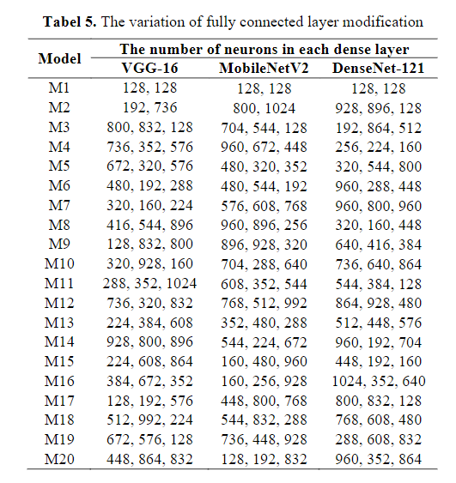

(Example: Equation)



(Example: Figure)

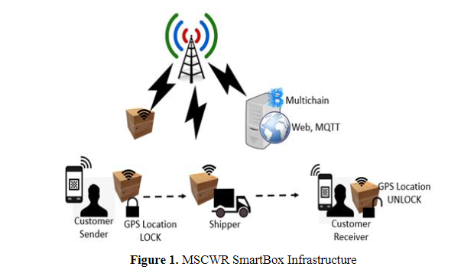

**5. Discussion** (Trebuchet-12)

Discussion is a crucial part of a scientific article where an in-depth interpretation of the results or findings of a study. The discussion should involve a dynamic process and comparison with some relevant previous studies based on specific scholarship. Discuss each finding carefully to produce representative conclusions and following the objectives of the study. This part should explore the significance of the results of the work, not repeat them. A combined Results and Discussion section is often appropriate. Avoid extensive citations and discussion of published literature. (Calisto MT-11)

**6. Conclusion** (Trebuchet-12)

The conclusion summarizes the results of the discussion of the results and findings of the study. This section is the main idea of the scientific article (main idea) that is in line with the purposes of the article. Suggest the conclusion present in 1-2 paragraphs. (Calisto MT-11)

**Recommendation** (If any)(Trebuchet-12)

Give advice or recommendations to parties who are relevant and related to this study. Suggestions should be specific, informative, and actionable (max 100 words). (Calisto MT-11)

**Limitations and avenue for future research**

Explain in one paragraph (max 100 words) the limitations of the article that we compiled are related to the purpose/problem, the data, and the method or design of the analysis. This article should also provide input for an avenue for future research. (Calisto MT-11)

**Funding**

Please supply all details required by any funding and grant-awarding bodies as Funding in a separate paragraph as follows:

* For single agency grants:
  + This work was supported by the <Funding Agency> under Grant [number xxxx].
* For multiple agency grants:
  + This work was supported by the <Funding Agency #1> under Grant [number xxxx]; <Funding Agency #2> under Grant [number xxxx]; and <Funding Agency #3> under Grant [number xxxx].

**Acknowledgment** (Trebuchet-12)

This section is an opportunity for the author(s) to thank those who have contributed to the research and the article, such as providers of research funds (grants), institutions/individuals who provide data or analytical facilities, and experts/reviewers who provide valuable input (max 60 words). (Calisto MT-11)

**Competing interests** (Trebuchet-12)

All relevant interests that might be seen as conflicting must be declared by the authors. Writers should explain why each conflicting interest exists. If there are no disputes, the writers should say this. The authors that submit the paper are responsible for co-authors reporting their conflicts of interest. (Calisto MT-11)

**ORCiD ID: (Author(s), if any)** [**https://orcid.org/signin**](https://orcid.org/signin)

**References** (Trebuchet-12)

*Citation in text*

*Author(s) sugested use references/papers on this manuscript for the last 10 years sourced from journals indexed by DOAJ, EBSCO, INSPEC, ESCI, GALE, Sinta, Copernicus, Scopus and/or WoS. The minimum of references is 20 papers and it is preferable to have a* ***DOI.*** (Calisto MT-10)

The journal uses the **APA** (American Psychological Association) 7th Edition Style (author-date method) short reference system for citations in the text with an alphabetical list at the end of the paper. Please ensure that every reference cited in the text is also present in the reference list and vice versa. Please check if all names and surnames of the authors, also the details (title, year, volume, pages, etc.) in the list of references are correct. Unpublished results and personal communications are not recommended in the reference list but may be mentioned in the text. Suppose these references are included in the reference list. In that case, they should follow the standard reference style of the journal and should include a substitution of the publication date with either 'Unpublished results' or 'Personal communication.'

In the text use the following style examples:

* This was explained by Allen (2020)" – single author item
* This was explained in full (Allen, 20206)" – single author item
* This was Concluded in full (Allen & Santosa, 2020) – two authors
* This was discussed in full (Huda et al., 2019)…" – 3 or more authors
* This was stated in full (P. Allen, 2019; S. Allen, 2020)…" where items have similar author names
* This was discussed in full (Allen, 2016a, 2016b)…" where two or more items are published in the same year

*Web references*

As a minimum, the full URL should be given and the date when the reference was last accessed. If known (DOI, author names, dates, reference to a source publication, etc.), should also give any further information. Web references can be listed separately (e.g., after the reference list) under a different heading if desired or included in the reference list.

*Reference style*

Text: Citations in the text should follow the referencing style used by the **American Psychological Association**. You are referred to the Publication Manual of the American Psychological Association, Sixth Edition. List: references should be arranged first alphabetically and then further sorted chronologically if necessary. More than one reference from the same author(s) in the same year must be identified by the letters 'a', 'b', 'c', etc., placed after the year of publication.

Examples:

**Reference to a journal publication:**

Santosa, P. W. (2020). Determinants of price reversal in high- frequency trading: empirical evidence from Indonesia. Investment Management and Financial Technology, 17(1), 173-187. doi:10.22511/imfi.17(1).2020.16

Conrad, J., Wahal, S., & Xiang, J. (2019). Blockchain-Driven IoT for Forest Traceability with an Integrated Consensus Mechanism, IEEE Access, 7, 129000–129017, doi: 12.1109/ACCESS.2019.2940227

**Reference to a journal publication with an article number:**

Van der Geer, J., Hanraads, J. A. J., & Lupton, R. A. (2018). The art of writing a scientific article. Heliyon, 19, e00205. doi:[10.1016/j.heliyon.2018.e00205](http://sci-hub.tw/10.1016/j.heliyon.2018.e00205).

**Reference to a book:**

Montgomery, D. C. (2012). *Introduction to statistical quality control* (7th ed.). London: Wiley.

**Reference to a book chapter:**

Slack, B. (2007). The terminalisation of seaports. In J. Wang, D. Olivier, T. Notteboom, & B. Slack (Eds.), *Ports, cities, and global supply chains* (pp. 41–50). Ashgate.

**Reference to a website:**

Cancer Research UK. Cancer statistics reports for the UK. (2003). http://www.cancerresearchuk.org/aboutcancer/statistics/cancerstatsreport/ Accessed 13 March 2003.

**Conference proceedings**

Saraiji, R., Harb, A., & Hamdan, M. O. (2011). Performance of LED street lights in hot environments. In K. Domke & C. A. Brebbia (Eds.), *Light in engineering, architecture and environment* (pp. 147–158). WIT Press. <https://doi.org/10.2495/LIGHT110131>

Brown, S., & Caste, V. (2004, May). *Integrated obstacle detection framework.* Paper presented at the IEEE Intelligent Vehicles Symposium, Detroit, MI.

**Thesis or dissertation**

Suwetwattanakul, C. (2010). *Developing a knowledge sharing model for the implementation of the learning organization in Thailand* (Unpublished doctoral dissertation/Thesis). Victoria University, Melbourne, Australia.

**Internet documents**

Bown, J. (2019, December 17). *How charity apps may be making us more generous*. BBC News. <https://www.bbc.com/news/business-50572939>

**Dataset:**

[dataset] Oguro, M., Imahiro, S., Saito, S., Nakashizuka, T. (2015). Mortality data for Japanese oak wilt disease and surrounding forest compositions. Mendeley Data, v1. <http://sci-hub.tw/10.17632/xwj98nb39r.1>.

***Subdivision - numbered sections***

Divide your article into clearly defined and numbered sections. Subsections should be numbered 1.1 (then 1.1.1, 1.1.2, ...), 1.2, etc. (the abstract is not included in section numbering). Use this numbering also for internal cross-referencing: do not just refer to 'the text'. Any subsection may be given a brief heading. Each heading should appear on its separate line.

***Appendices***

If there is more than one appendix, they should be identified as A, B, etc. Formulae and equations in appendices should be given separate numbering: Eq. (A.1), Eq. (A.2), etc.; in a subsequent appendix, Eq. (B.1) and so on. Similarly, for tables and figures: Table A.1; Fig. A.1, etc.

# Notes: Articles should be between 6000  and 8000 words in length. This includes all text, for example, the structured abstract, references, all text in tables, and figures and appendices.